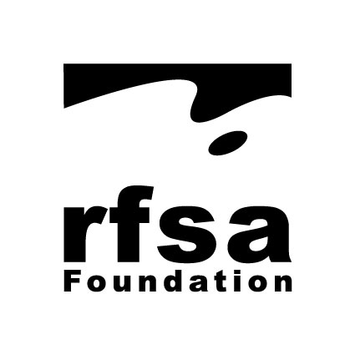
Royal Female School of Art Foundation
Widening Access to Arts Education in Greater London
Grant claim form and checklist
Please return this completed claim form with your grant claim documents, duly signed by a senior manager at dean/head of department level or above
1. | TOTAL AMOUNT OF GRANT CLAIMED: | £ …………………..
2. | BURSARY GRANTS ONLY |  | Enclosed?
 | Please provide a summary sheet showing:  - Total amount awarded in bursaries.  - Total number of grants awarded/ students supported.  - Recipient female:male ratio, plus disability, carer, BAME stats.  - Amount awarded to each student, incl. initials (only) of each student.  - Explanation of how bursaries were awarded and how this met the RFSA’s charitable purpose. |  | Yes/no
3. | ALL OTHER GRANTS |  | Enclosed?
3.1 | Please provide an itemised summary sheet setting out:  - Total expenditure incurred.  - A numbered list of all items of expenditure which also correlates to the main headings of expenditure shown in the approved application. |  | Yes/no
3.2 | Please provide numbered copies of receipts or other proofs of expenditure connected to the numbered list in 3.1 ii above in the same order. |  | Yes/no

Please also complete and sign below sections:

4. | I CONFIRM THAT I HAVE CHECKED THIS CLAIM AND IT IS ACCURATE:  ……………………………………………………………………………………………………………  Signature  NAME …………………………………………………………………………………………………  Date ………………….  POSITION IN ORGANISATION……………………………………………………..…………..…  Direct tel no: ………………………………………..................  Email:………………………………………………………………….…
5. | NAME OF CONTACT RESPONSIBLE TO RFSA TRUSTEES FOR THIS GRANT CLAIM:  ……………………………………………………………………………………………………………(in capitals please)  POSITION IN ORGANISATION……………………………………………………………...  Direct tel no: …………………………………………………….…..  Email:…………………………………………………………………….
6. | ORGANISATION BANK ACCOUNT DETAILS FOR GRANT PAYMENT  Account Name: ……………………………………………………………………………………………………………………  Account No: …………………………………………………………..  Sort Code: ………………………………………………………….….  Reference for Grant Payment: ……………………………………………………………………………………………..

Please scan and return by email to the Foundation Secretary & Grants Manager via email: admin@rfsafoundation.org
Claims to be submitted by 1 October (following academic year of award).

